**Realization of Logic Gate Using Universal gates**

In Boolean Algebra, the **NAND** and **NOR** gates are called **universal gates** because any digital circuit can be implemented by using any one of these two i.e. any logic gate can be created using NAND or NOR gates only.

Every logic gate has a representation symbol. The below image shows a graphical representation of all [logic gates](https://www.geeksforgeeks.org/introduction-of-logic-gates/).

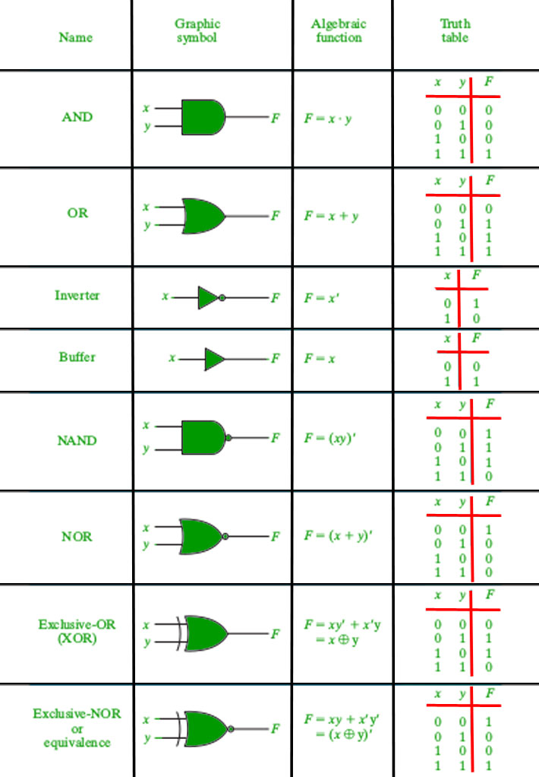

*Graphical representation of logic gates.*

**1. Implementation of AND Gate using Universal gates.**

**a) Using NAND Gates**

The AND gate can be implemented by using two NAND gates in the below fashion:

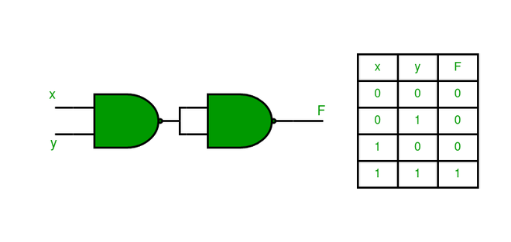

**b) Using NOR Gates**

Implementation of AND gate using only NOR gates as shown below:

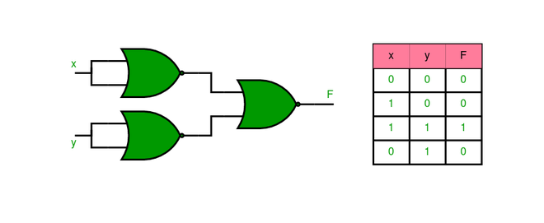

**2. Implementation of OR Gate using Universal gates.**

**a) Using NAND Gates**

The OR gate can be implemented using the NAND gate as below:

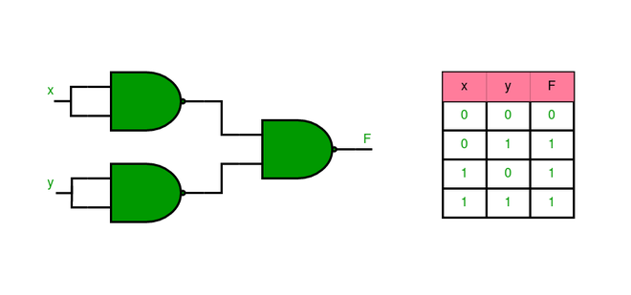

**b) Using NOR Gates**

Implementation of OR gate using two NOR gates as shown in the picture below:

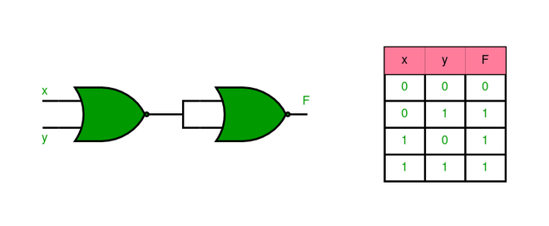

**3. Implementation of NOT Gate using Universal gates.**

**a) Using NAND Gates**

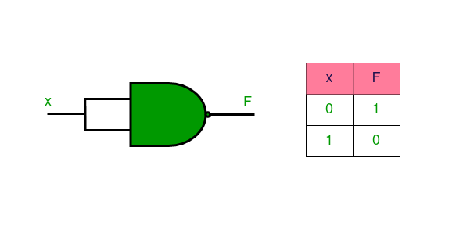

**b) Using NOR Gates**

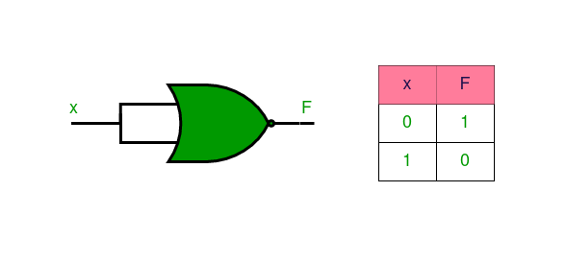

**4. Implementation of XOR Gate using Universal gates.**

**a) Using NAND Gates**

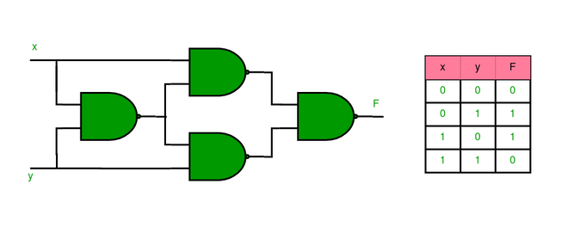

**b) Using NOR Gates**

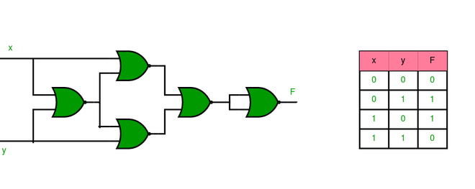

**5. Implementation of XNOR Gate using Universal gates.**

**a) Using NAND Gate**

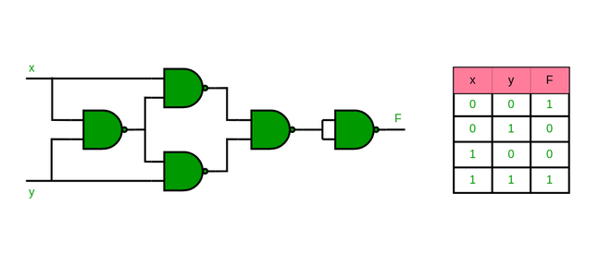

**b) Using NOR Gate**

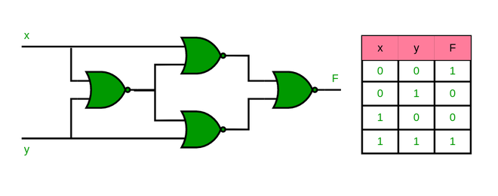

**6. Implementation of NOR Gate using NAND Gates**

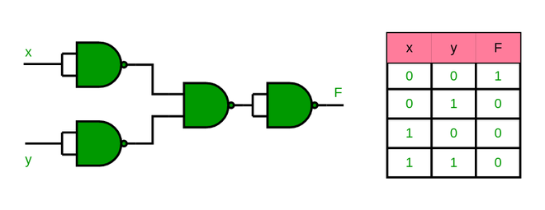

**7. Implementation of NAND Gate using NOR Gates**

